AI Camera 2.0 Basic Projects

Lesson 4: Emotion Recognition and Emoji Feedback
Ages: 12 and up
Duration: 45 minutes

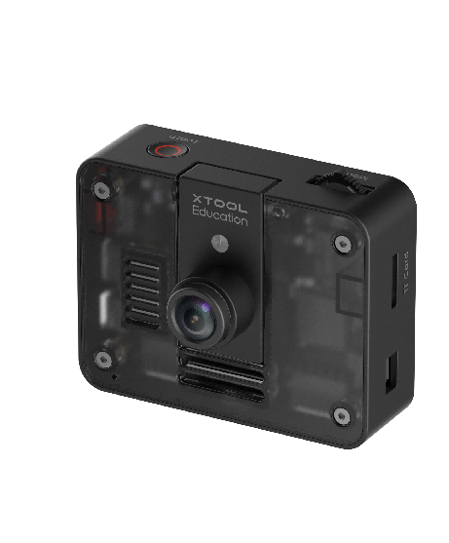

Objectives:
By the end of class, students will be able to:
- Understand the basic concepts of facial recognition and emotion recognition
- Use graphical programming to recognize facial emotions
- Display corresponding emojis on the CyberPi screen

Overview
This course guides students to explore the facial recognition and emotion recognition functions of the AI Camera, experiencing the application of artificial intelligence in visual perception. Students will learn how to register facial data and write programs to enable the CyberPi to display corresponding emojis based on recognized emotions (such as happiness, surprise, and sadness). Through this project, students will understand the basic principles of facial recognition technology and consider its applications and impacts in real life.

Pre-lesson Checklist
For the teacher:
- Computer with mBlock installed and tested;
- AI Camera, CyberPi, and connecting cables;
- Ensure appropriate classroom lighting to facilitate facial recognition;
For the students:
- Computer with mBlock installed and ready;
- AI camera set per group;
- CyberPi and connection cable;
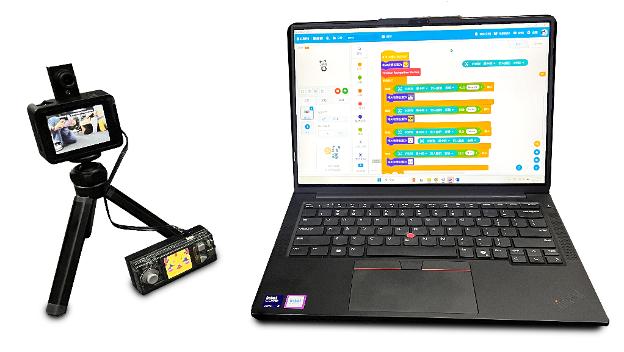

Agenda (45minutes)
Duration | Content
5 minutes | Section 1 - Introduction  - Demonstrate the facial recognition, facial data enrollment, and emotion recognition functions of the AI Camera;
10 minutes | Section 2 - Explore  - Learn the basic principles of facial recognition;  - Understand the fundamentals of emotion recognition;
15 minutes | Section 3 - Create and practice  - Set up the programming environment and activate the facial recognition function;  - Program to achieve emotion recognition and display corresponding AI emojis;
10 minutes | Section 4 - Presentation  - Invite 2-3 groups of students to demonstrate their emotion recognition projects;  - Discuss application scenarios of facial recognition technology;
5 minutes | Section 5 - Evaluate  - Review the problems they met and how they solved;  - Explore other real-life applications of facial recognition technology;

Activities

Section 1 - Introduction
In this lesson, we will explore facial recognition and emotion recognition technologies in artificial intelligence. Students will discover that the AI Camera can not only recognize different faces through its facial recognition function but also "read" our emotions. We will operate the AI Camera firsthand to register our facial information and write programs to enable the CyberPi to become an intelligent device capable of responding to our emotions.

Section 2 - Explore
To understand how the AI Camera works, we need to explore from two perspectives:
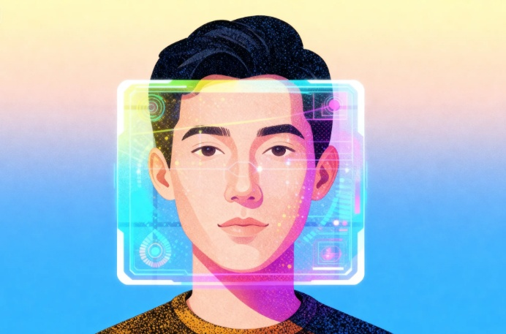
Basic Principles of Facial Recognition: Feature Extraction and Matching
The AI Camera extracts geometric features of key facial points (such as facial contours and relative positions) and converts them into unique digital feature codes. During recognition, the system quickly compares the real-time generated feature codes with those stored in the database, completing identity verification by calculating similarity.
Basic Principles of Emotion Recognition: Keypoint Variation and Classification
The AI Camera continuously tracks subtle positional changes in key facial points (such as the corners of the mouth, eyebrows, and eyes). By learning the correspondence between these muscle movement patterns and emotion categories from vast amounts of data, it builds a classification model. During actual recognition, it captures current facial movement features and compares them with the model to determine the most likely emotional state.

Section 3 - Create and practice
In this session, students will work in groups to set up the programming environment and complete a creative project that responds to recognized emotions.
Task 1: Set up the programming environment and activate the facial recognition function
Step 1: Programming environment configuration. Add the [AI Camera 2.0]and [Magic Emoji] extensions in mBlock 5. Then, write the [Face Recognition Startup] function to initialize the camera connection and activate the facial recognition feature. | 
Step 2: Emotion recognition function activation. We need to ensure that the AI Camera displays "Face Recognition" and the CyberPi screen shows a ready prompt, indicating successful activation of the facial recognition function. | 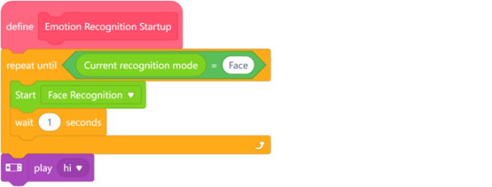

Task 2: Emotion Recognition and Emoji Display Implementation
Step 3: Build the control logic framework. Use [If-else] conditional logic blocks to construct decision-making branches for different emotional states.  Step 4: Implement emotion recognition and emoji feedback. Use conditional statements to continuously obtain emotion categories (e.g., happy, surprised, sad, angry) identified by the AI Camera, and control the CyberPi screen to display corresponding AI emojis based on the results. | 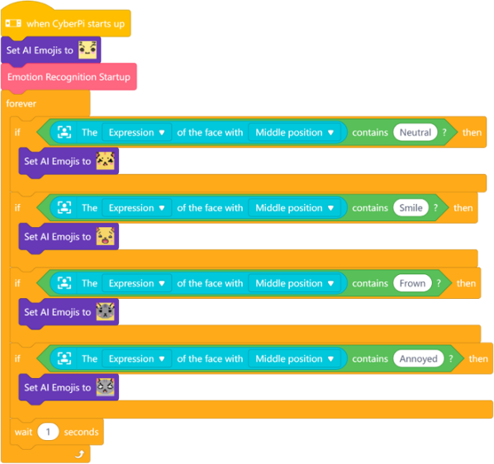

Section 4 - Presentation
In this session, each group will be invited to demonstrate their completed emotion recognition project. They will explain which emotions they mapped to specific emoji feedback and share the most creative or satisfying aspects of their design.
After 2-3 groups have presented, the teacher will facilitate a class discussion exploring real-world applications of facial and emotion recognition technologies beyond this classroom project.

Section 5 - Evaluate
Now let's review some key points in this lesson.
- What was the biggest challenge you faced in today's project? How did you and your team work together to solve it?
- If you were to further optimize this project in the future, what features would you add or improve?
- In what areas of daily life has facial recognition technology already been applied?

